1. Architectural Design & Justification
1.1 Architectural Overview
In this section, define the organizing principle of your Lost and Found system.
- System Scale: The project follows Architecture in the Small, focusing on the decomposition of a single program into components.
- Primary Strategy: To manage uncertainty regarding future requirements and technology choices, we have adopted a high-level infrastructure that prioritizes modularity and separation of concerns.
- Selected Patterns: The system integrates Layered Architecture and the Model-View-Controller (MVC) pattern.

1.2 Pattern 1: Layered Architecture
Explain the horizontal organization of your system.
- Definition: This style organizes the system into a set of layers, where each layer provides services to the one immediately above it.
- Suitability: This is highly suitable for an information system like ours because it models the interfacing of sub-systems (UI, Logic, and Data).
- Support for Requirements:
  - Data Isolation: By keeping the database in an inner layer, we protect critical assets.
  - Incremental Development: Since our team has five members, this pattern allows us to develop sub-systems in different layers simultaneously.
- Code Reference: The Repository classes represent the Data Access Layer, while the Service classes act as the Business Logic Layer.

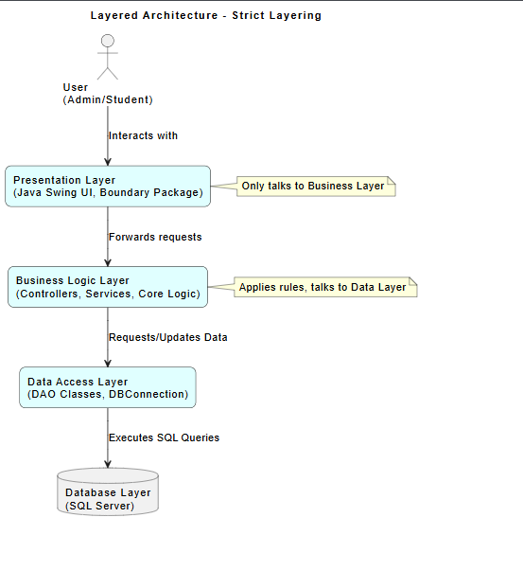

1.3 Pattern 2: Model-View-Controller (MVC)
Explain how you separate the UI logic from the data handling.
- Definition: MVC separates the system into three logical components: the Model (data management), the View (data presentation), and the Controller (interaction logic).
- Suitability: This is used because the "Lost and Found" system requires multiple ways to interact with data (e.g., student search vs. admin management).
- Support for Requirements:
  - Independent Change: It allows the user interface (View) to be updated or replaced (e.g., changing from a desktop app to a web browser) without modifying the core logic.
  - Control Flow: The Controller manages key presses and mouse clicks, passing these to the Model to update item states.
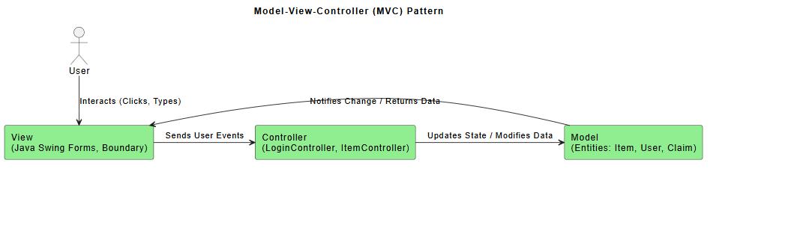

1.4 Complementary Relationship
- Macro vs. Micro: Layered Architecture provides the global structure, while MVC is implemented within those layers.
- Mapping:
  - The MVC View lives in the Presentation Layer.
  - The MVC Controller lives in the Business Layer.
  - The MVC Model interacts with the Data Access Layer.
- Benefit: This combination ensures the system is logically organized to support non-functional requirements like security while remaining flexible enough to support multiple UI views.

2. Non-Functional Requirements (NFRs) Mapping
Identify how your architectural decisions satisfy the quality attributes required by the doctor.

Non-Functional Requirement How Architecture Supports It
Security:
We utilize Layered Architecture to keep the core assets (the system database) in the innermost layer, isolated from direct user contact by the Business and Presentation layers.
Maintainability:
By using fine-grained, replaceable components in the MVC pattern, individual features or UI elements can be updated without necessitating a system-wide overhaul.
Performance:
Critical operations are localized within the Business Layer to minimize communication overhead between distant components, which is a key strategy for maintaining speed.
Scalability:
The MVC pattern allows the system to scale by adding new views or interfaces (e.g., a web-based dashboard) while reusing the same underlying Model and Business Logic.
Availability:
The decoupled nature of the layers enables the future inclusion of redundant components or fault-tolerance mechanisms specifically within the data tier without affecting the UI.

